Journal of resources used

Time spent: Approx 3 hours

<https://pypi.org/project/mysql-connector-python/>

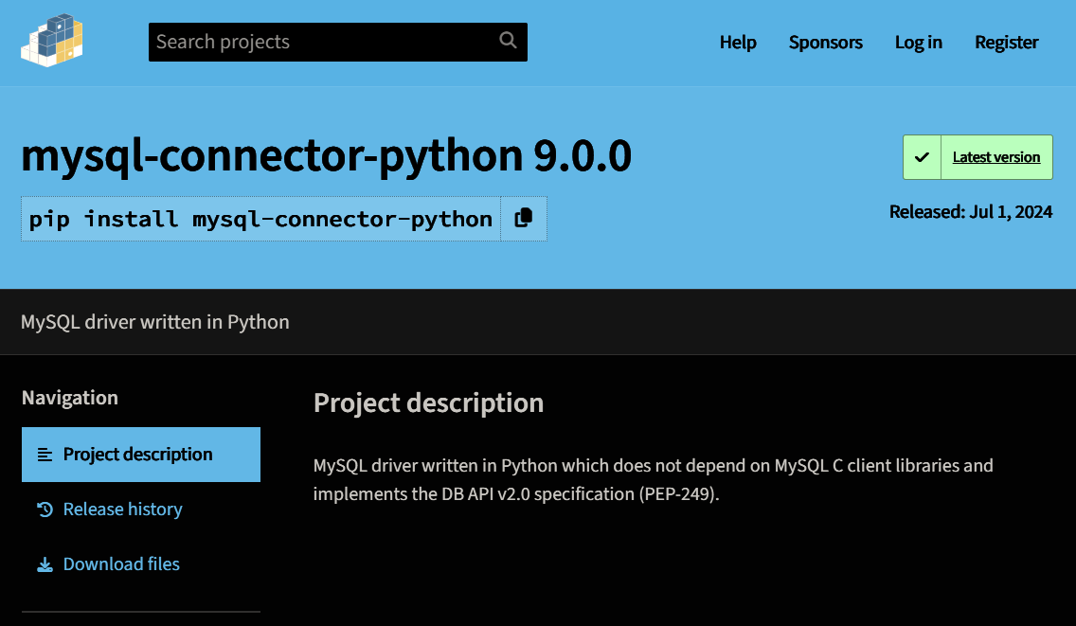

This website was very helpful in getting mysql-connector installed. I just clicked the copy button and pasted into VScode. pip needed an update and mysql-connector was installed. Very easy, I really like the copy button.

<https://youtu.be/3vsC05rxZ8c?si=yEx8dewrOtHSGMR6>

<https://youtu.be/Sxd8rQHCPcA?si=k_9ImYYbG073k46Q>

Once mysql-connector was installed, the videos were very helpful in testing the module.

<https://www.w3schools.com/python/python_mysql_getstarted.asp>

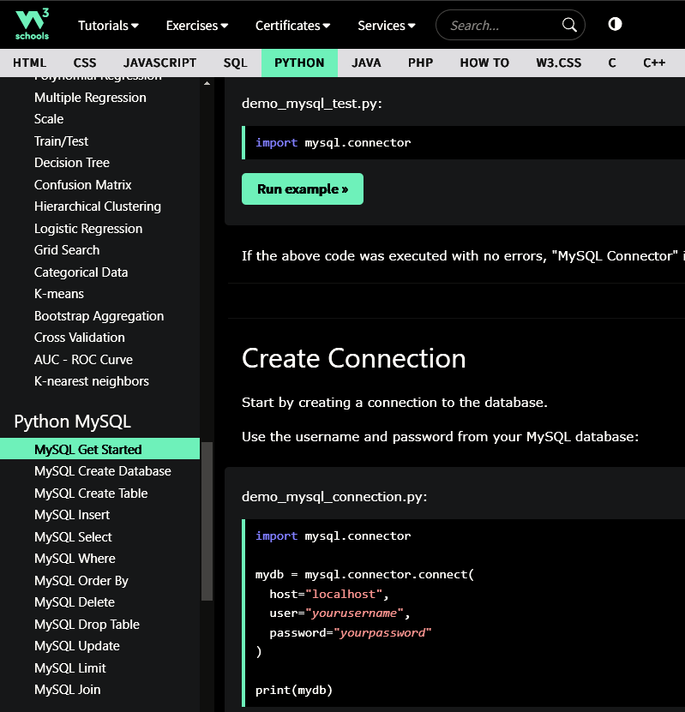

I read and tested code from "Get Started" thru "Join", shown bottom left. Also very helpful in testing and learning how to query the database.

Screen shot of my test code and results after using W3schools website examples and some of my own testing ideas.

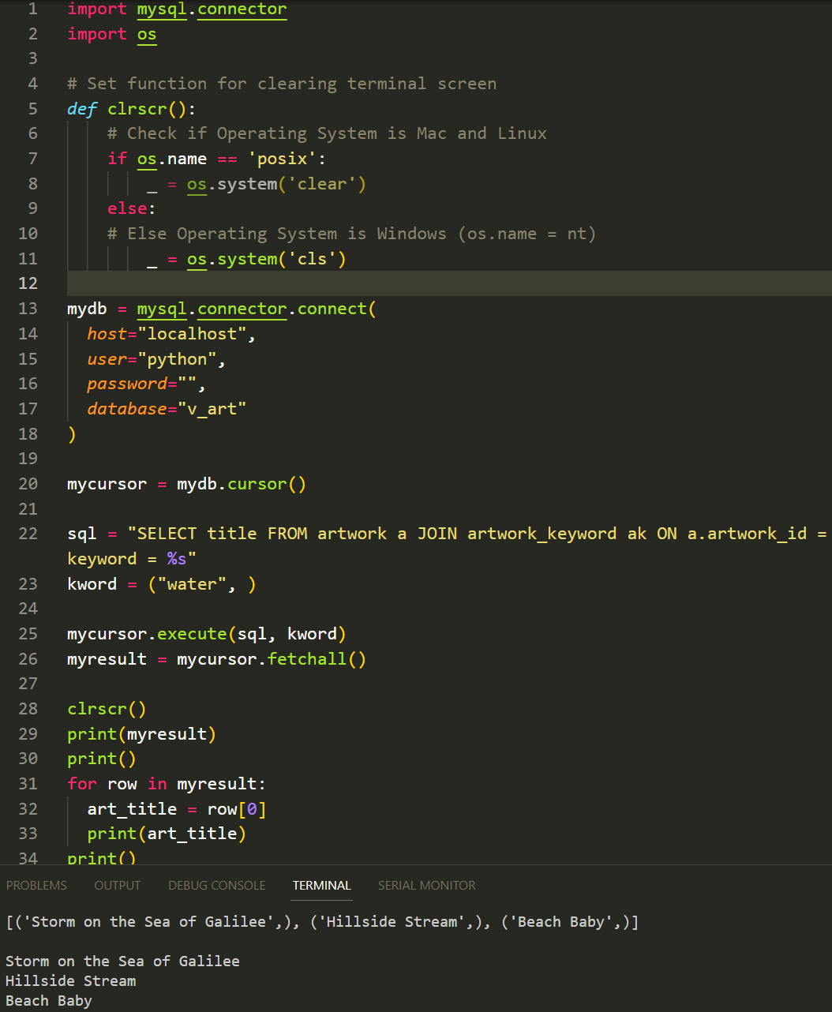

After the initial tests on July 10th I began building the Artwork Search program.

I ended up coding overnight and into the next morning, approx 12 hours.

I used many Google searches to remind me of how to use For Loops, make and retrieve data from lists, using SQL queries in Python code and more.

In my searches I found two modules that were extremely helpful. One is the Pathlib module for finding the ROOT path of the Python program and thereby being able to find the picture files. The other module is called webbrowser. This module allows you to open a browser or default photo app for the displaying of pictures.

At the end of this set of 12 hours I had the search by artist part completed and working. I spent about 4 - 5 hours building the SQL Database and inserting, updating and correcting the data in the DB tables and linking tables. Also searched Google to find good pictures of each of the works of art.

On July 12th I worked for about 8 hours and got the search by keyword part of the program working.

After some testing and having other people try the program, there were a couple of suggestions which I thought were worth trying to implement.

On July 13th I worked on implementing these suggestions, which are:

Since some artists or keywords had multiple artworks listed I should make it so you can go back to choose more than one picture before returning to the main menu / welcome screen. This turned out to be fairly easy to do.

I spent about 8 hours making the above changes, cleaning up the code, catching misspellings, realigning text and adding comments to the code.

All together I spend about 32 hours working on the database, getting Python and SQL linked and writing the functions and displays.

Next I will write a test programs to test a couple of the functions in my program.